*When you plot the distribution on these new data points , It follows Normal distribution*

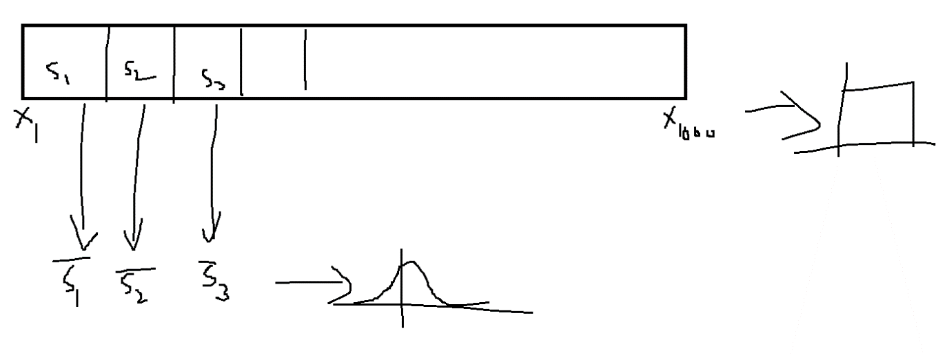

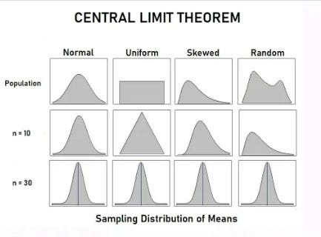

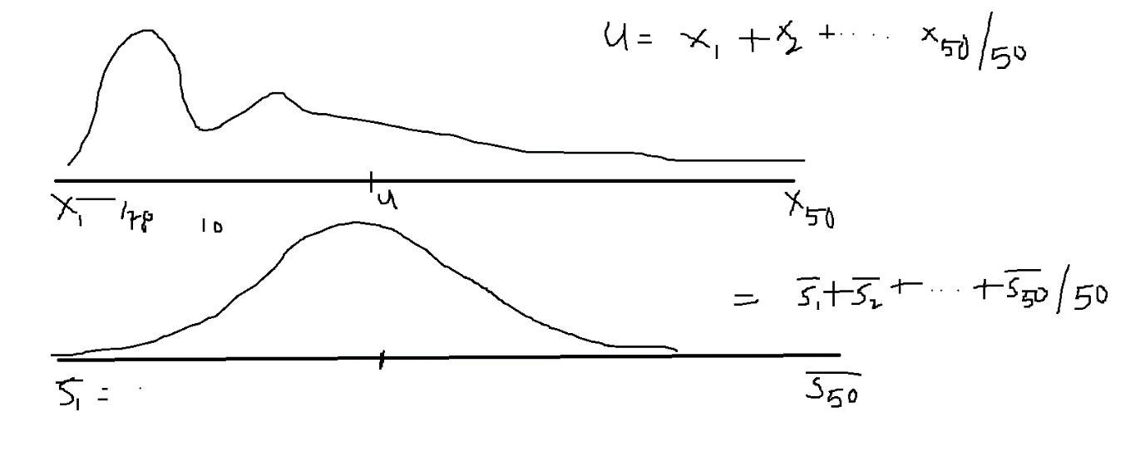

*)/5  
)/5=*

|  |  |  |
| --- | --- | --- |
|  |  |  |
|  |  |  |
|  |  |  |
|  |  |  |

|  |  |
| --- | --- |
|  |  |
|  |  |
|  |  |
|  |  |